Lab 16: Securing Data with Encryption Software

1 Creating a VeraCrypt Container

* 1. Creating a Container

1. Launch the kali VM
2. Log in with credentials provided
3. Right-click on an empty space on the desktop, then select Open Terminal Here.
4. In the Terminal window, type touch billing.txt to create a text file.
5. Launch the VeraCrypt application by typing veracrypt in the Terminal window, followed by pressing the Enter key

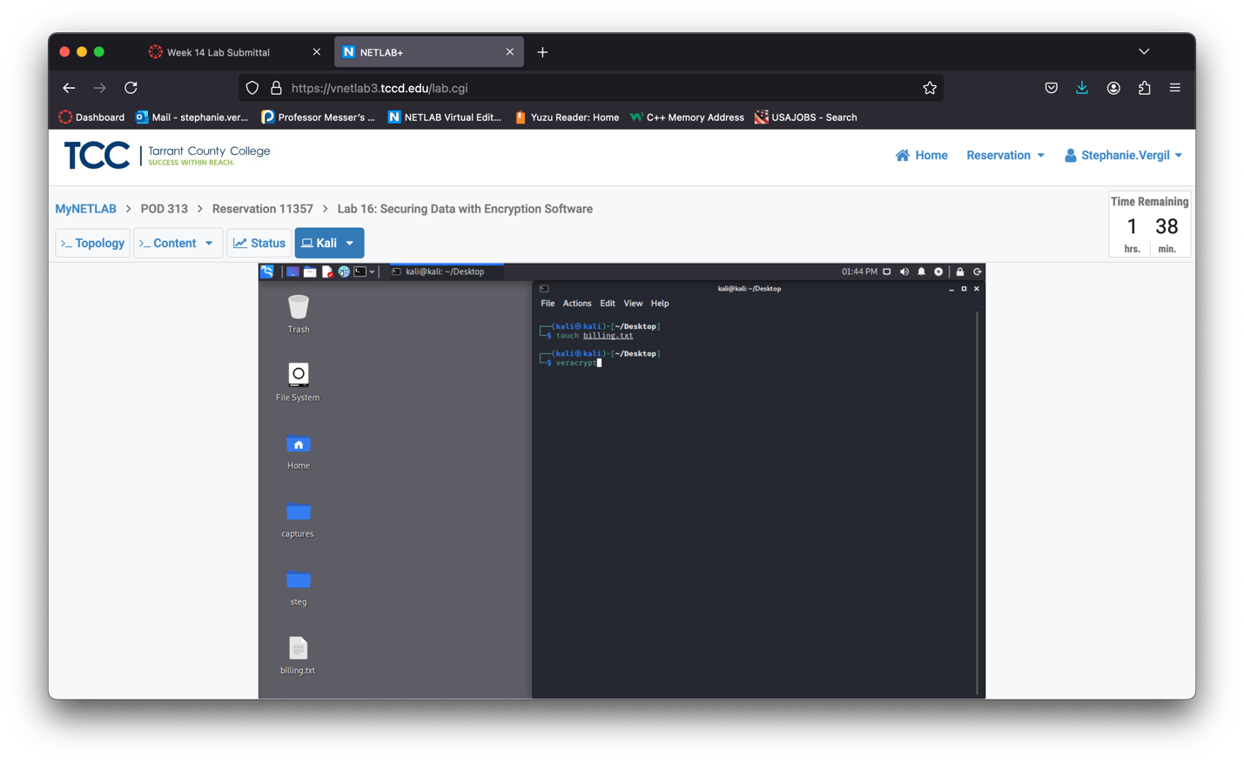

1. In the VeraCrypt application window, click the Create Volume button.
2. Notice the VeraCrypt Volume Creation Wizard appears. Proceed with creating an encrypted file container by selecting the radio button for Create an encrypted file container and clicking Next.

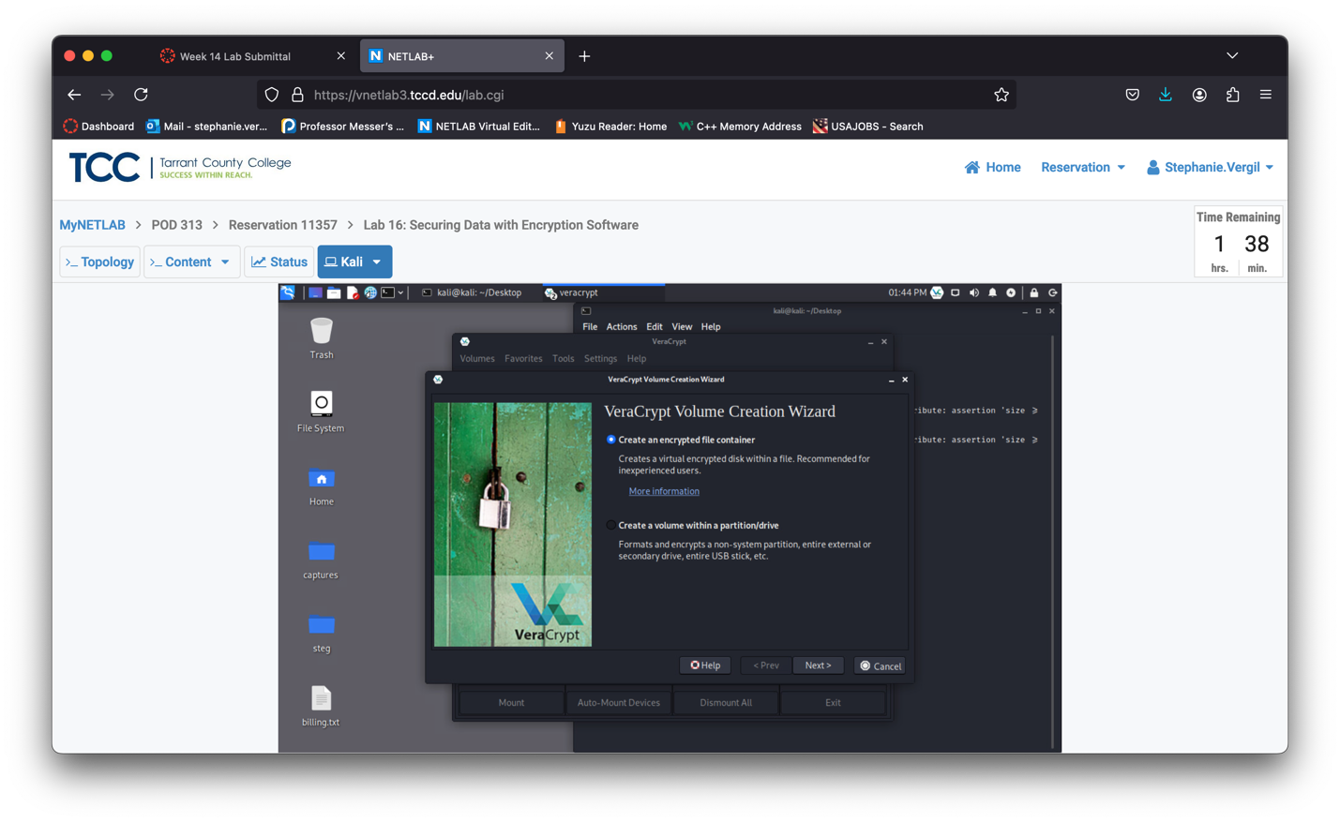

1. On the Volume Type step, select the radio button for Standard VeraCrypt volume and click Next.

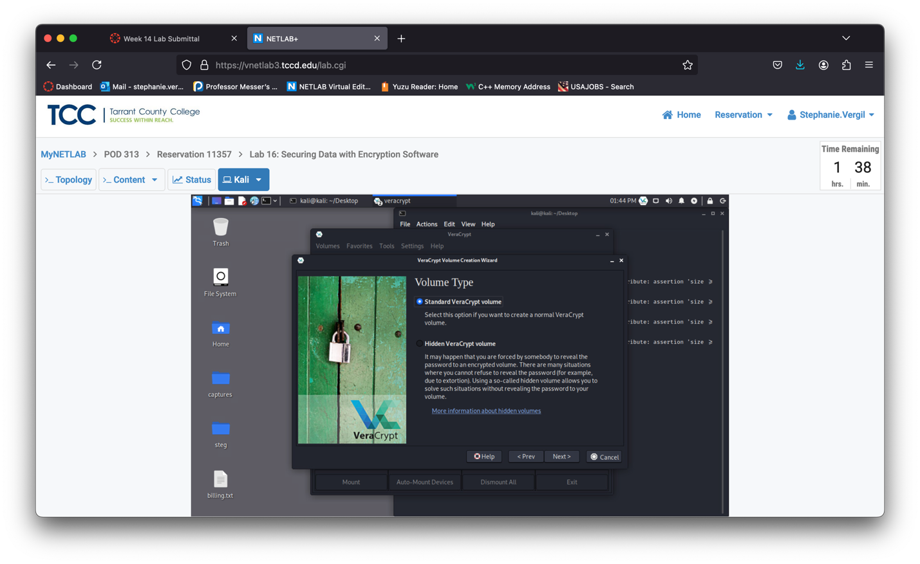

1. On the Volume Location step, click on the Select File button.
2. A new File Manager window appears. Navigate to Desktop. Select the billing.txt file and click Save.

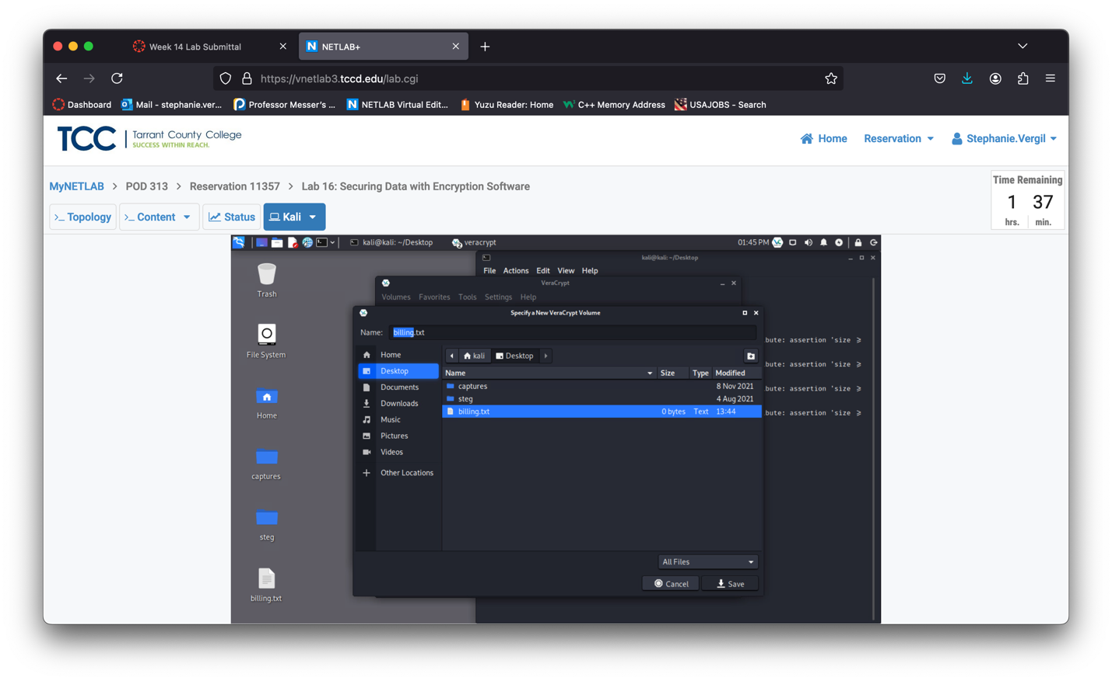

1. When asked to replace the file, click on Replace.

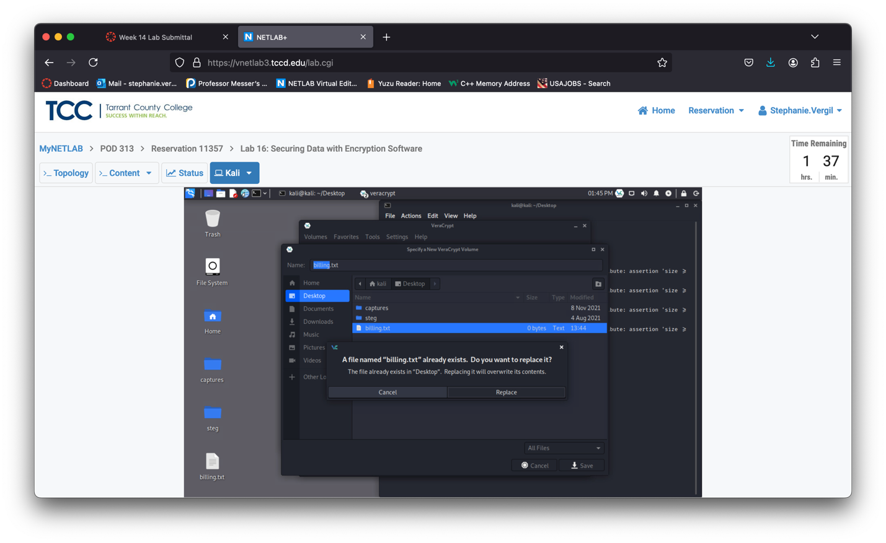

1. Back on the VeraCrypt Volume Creation Wizard window, verify that /home/kali/Deskop/billing.txt is prefilled in the Location field and click Next.

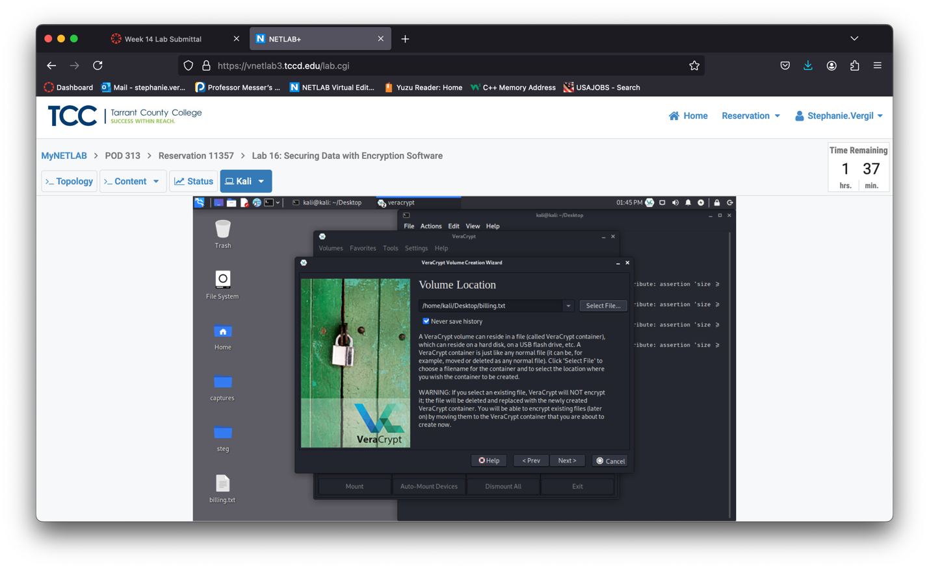

1. On the Encryption Options step, leave the default set to AES and SHA-512. Click Next.

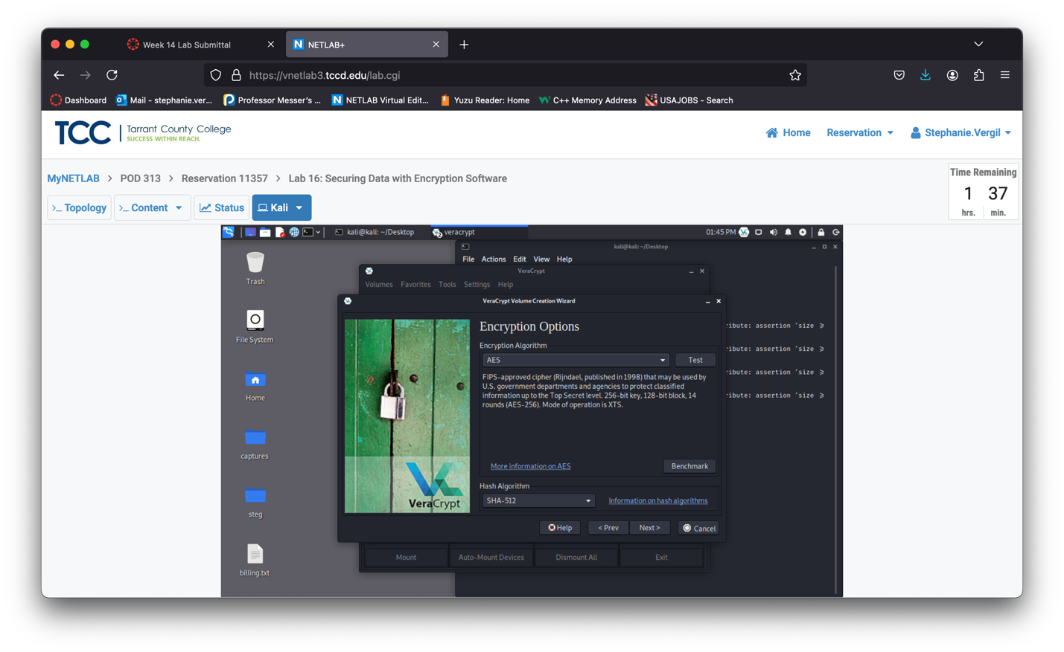

1. On the Volume Size step, enter the value of 50. Verify MB is selected and click Next.

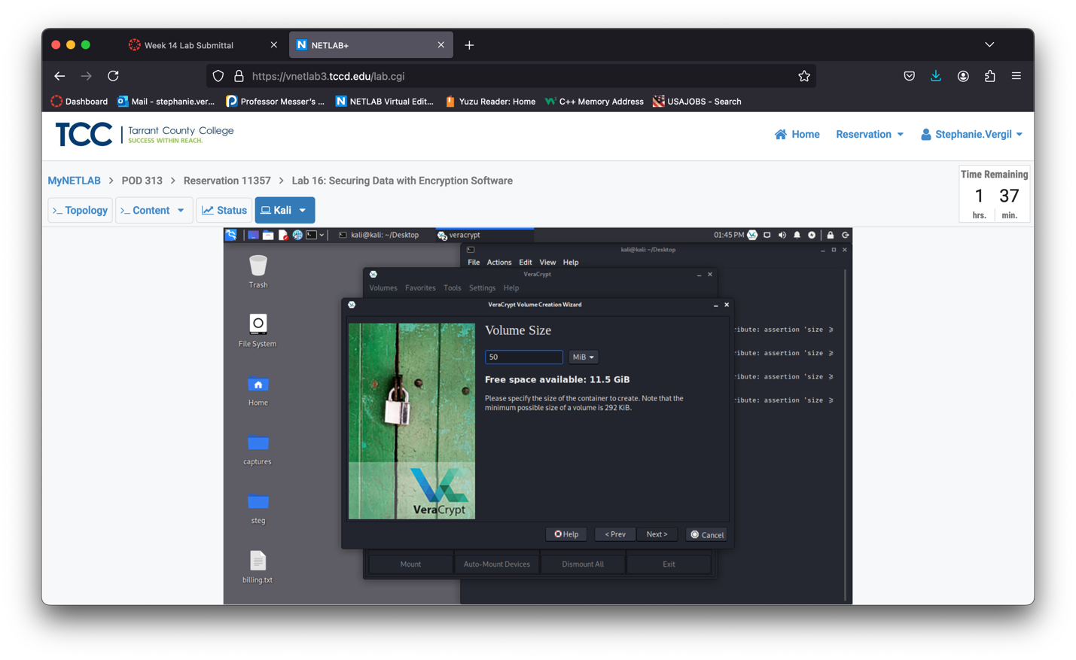

1. On the Volume Password step, type password and confirm the password of password. Click Nex

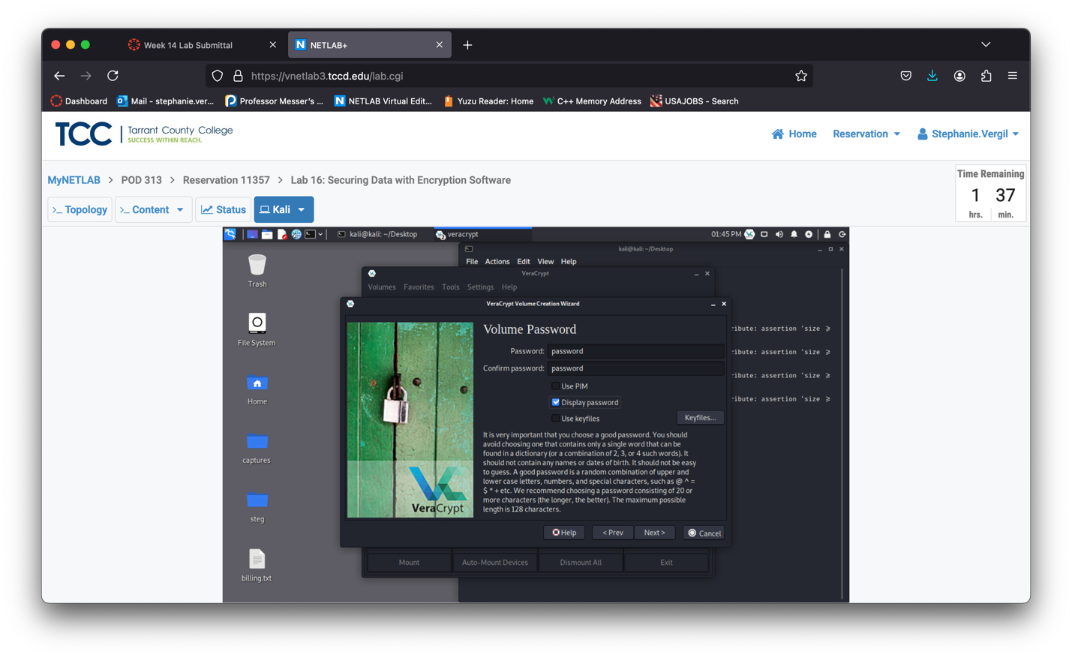

1. When prompted with a warning, click Yes to continue.

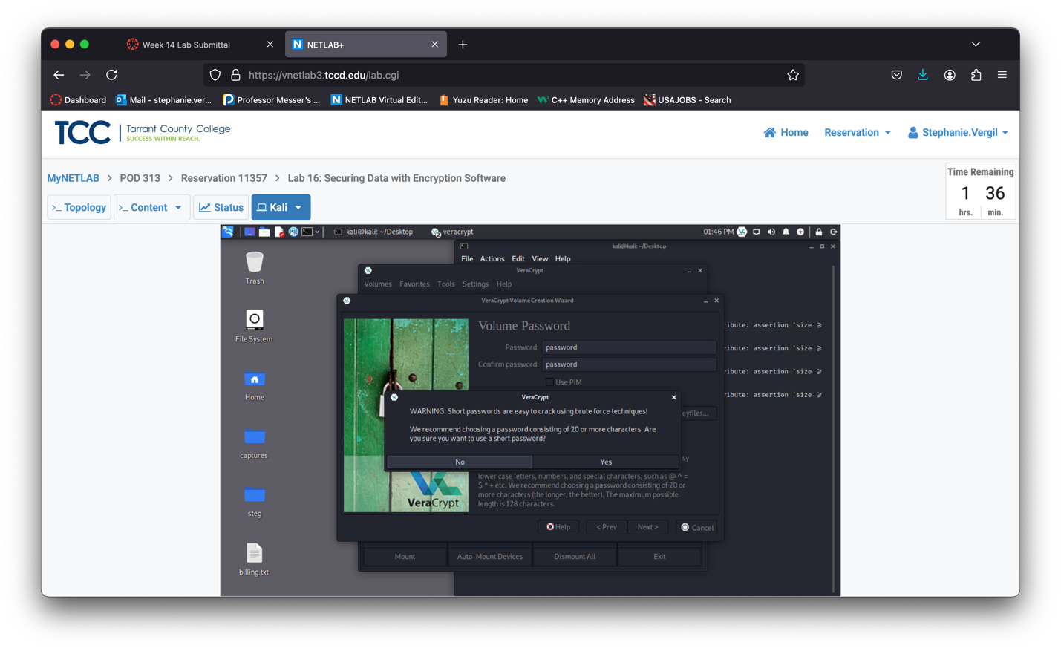

1. On the Format Options step, leave the default set to FAT and click Next.

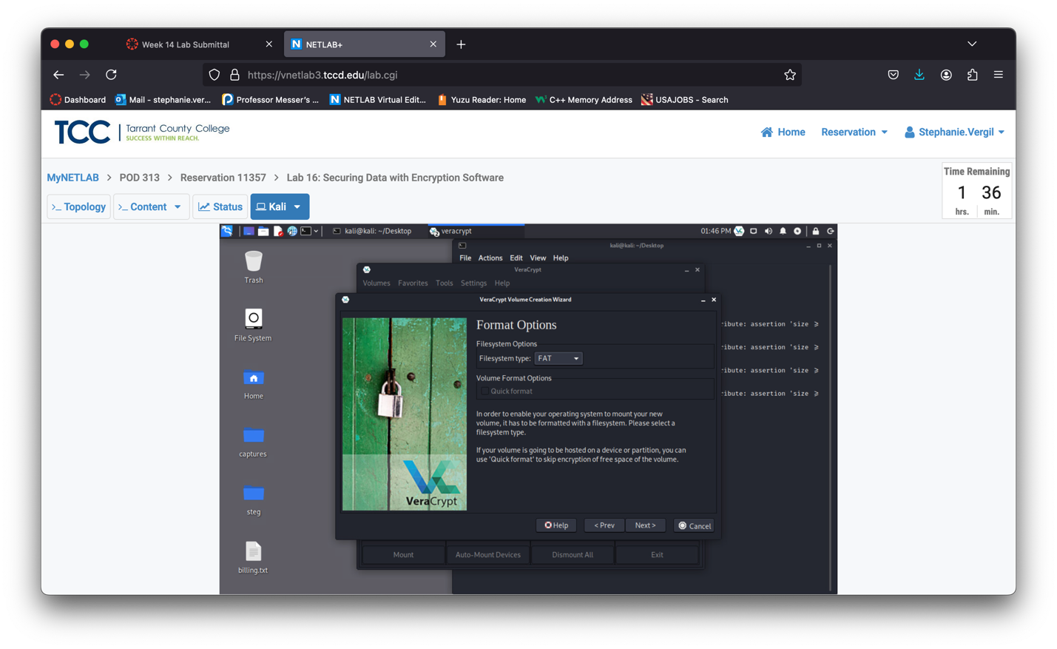

1. On the Volume Format step, the VeraCrypt software will collect the mouse movement as a factor for generating the encryption key, so keep moving your mouse at this screen until you are satisfied with the Randomness level (shown in blue). Then, click Format.

Note: The higher the randomness, the securer the encryption.

1. When prompted with a warning message, click Yes to replace the billing.txt file with a Veracrypt container.

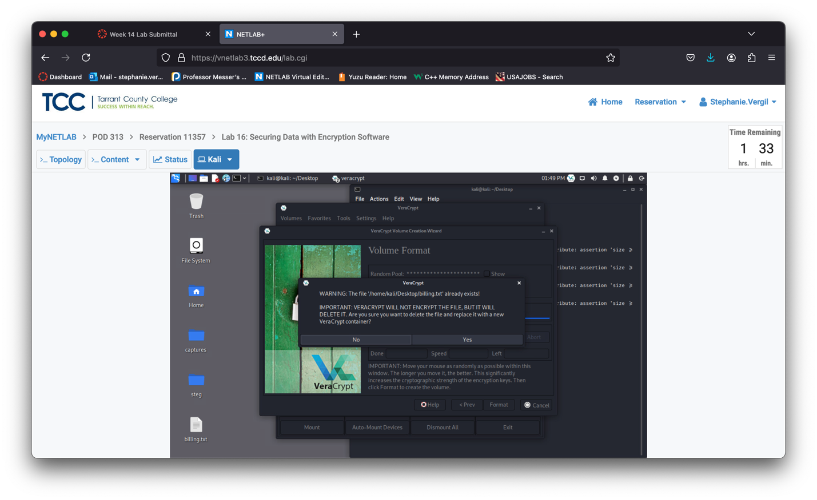

1. Click OK in response to the successful operation message.

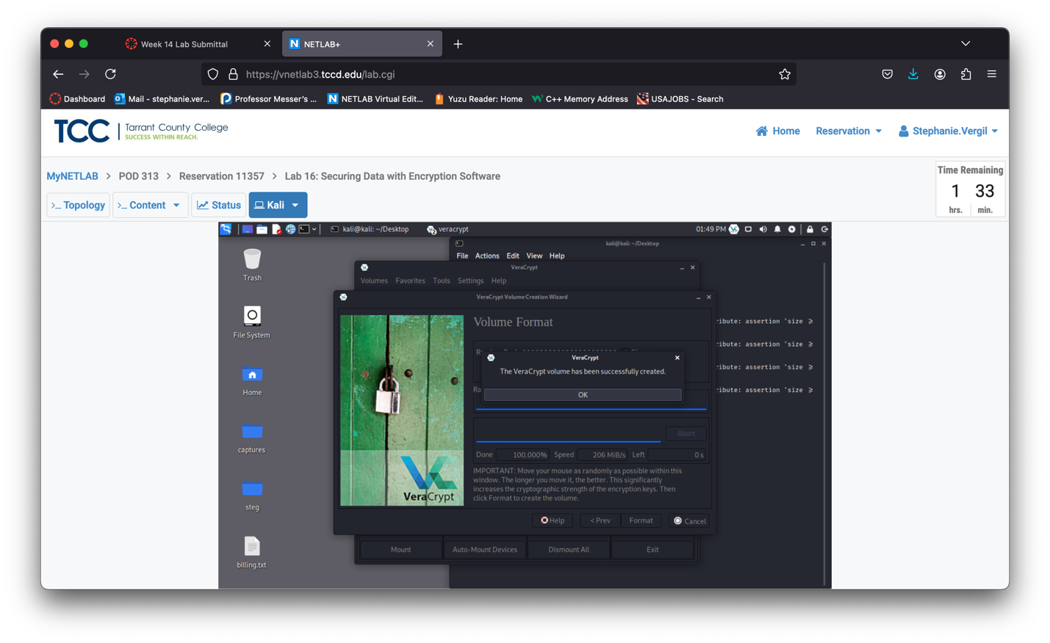

1. Click Exit on the Volume Created screen to exit the VeraCrypt Volume Creation Wizard window

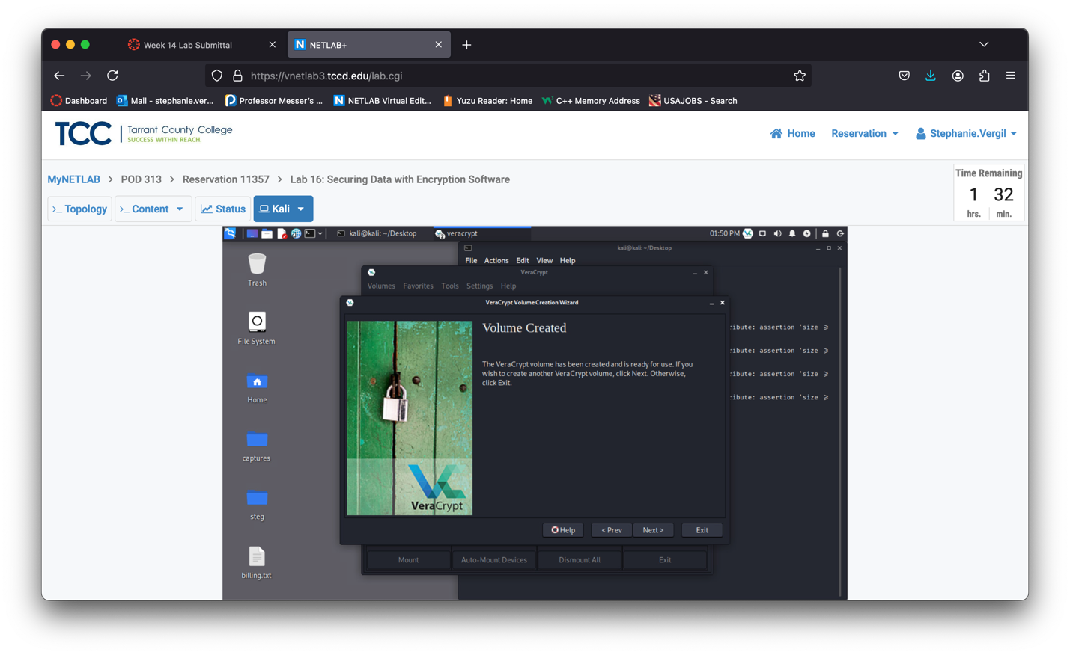

1. Leave the VeraCrypt application open to continue with the next task

2 Opening and Viewing Data within a VeraCrypt Container

2.1 Using the VeraCrypt Container

1. While on the Kali system with the VeraCrypt application opened, click on the Select File button to locate your VeraCrypt container.
2. A new File Manager window appears. Navigate to Desktop and select the billing.txt file. Click Open.
3. Select one available drive slot from the list and then click on the Mount button.
4. When prompted for a password, type password and click OK

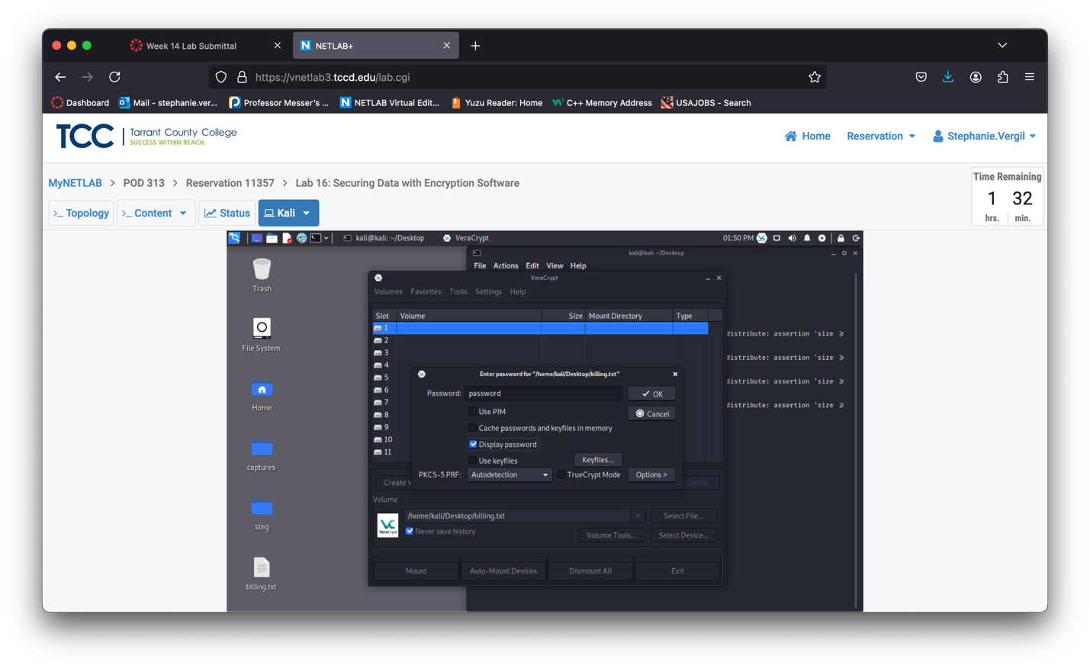

1. When prompted for Administrative privilege enter kali. Then click OK.

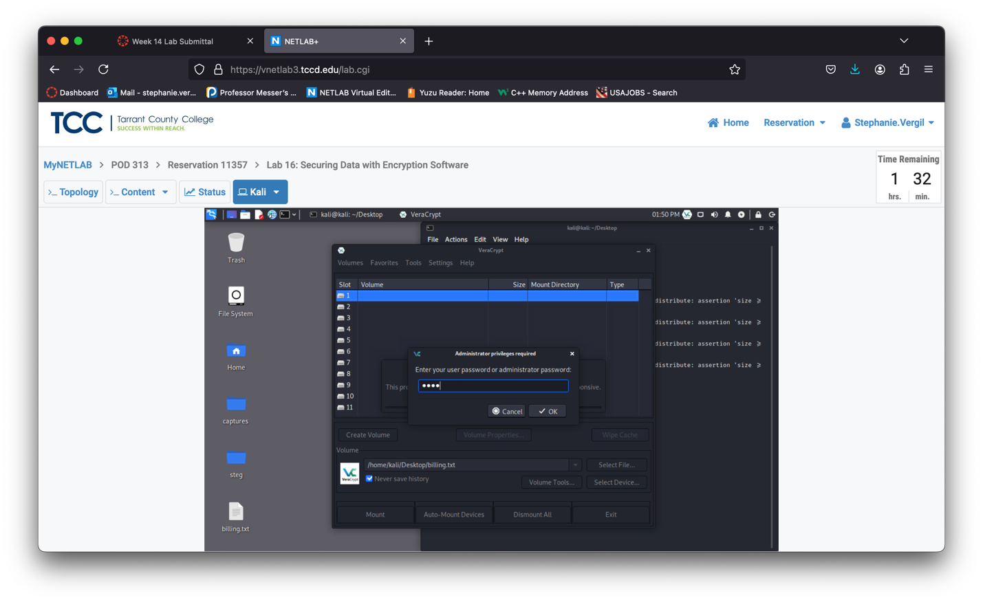

1. Notice that the drive is now successfully mounted when looking at the VeraCrypt window with the mount directory information presented as /media/varecypt1. There should be a drive appearing on the desktop.

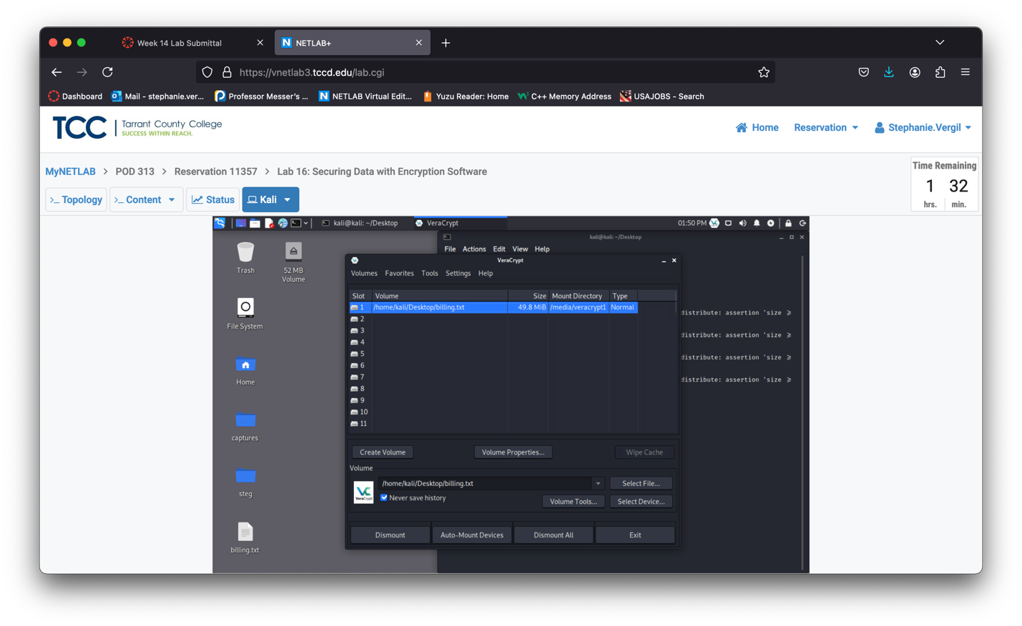

1. On the steg folder located on the desktop double-click to open it. You should see two pictures.

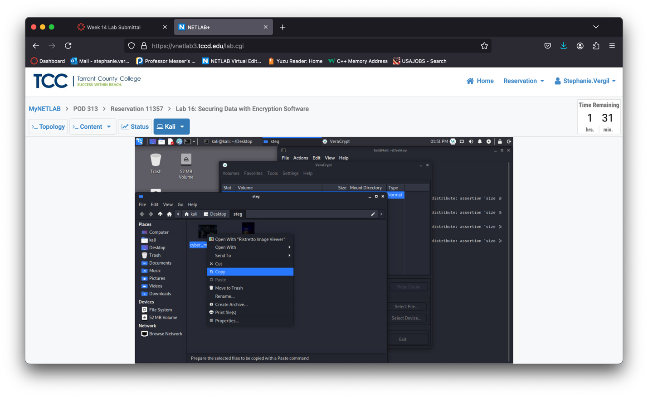

1. Click on the veracrypt1 52MB Volume located on the left menu pane.
2. Right-click in the white space and select Paste. (or Ctrl + V to paste)

Note: The files should now all be in the VeraCrypt container.

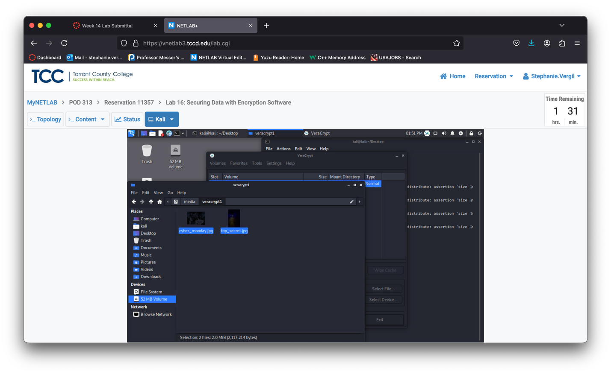

1. Close the File Manager window.
2. Change focus back to the VeraCrypt application window. Click on the Dismount button to unmount the veracrypt1 volume
3. The mounted drive should disappear from the desktop.

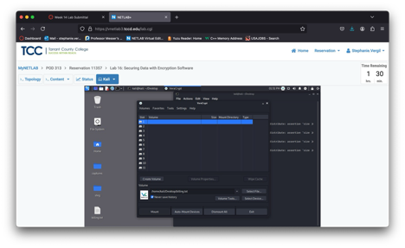

1. Lab is now completed.